**Logic apps and web activity**

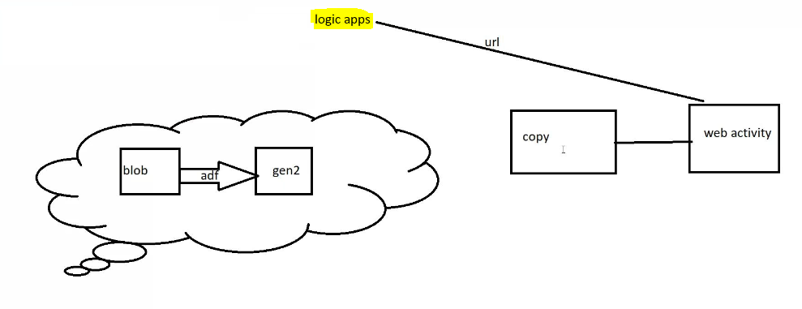

Create blob syorage:

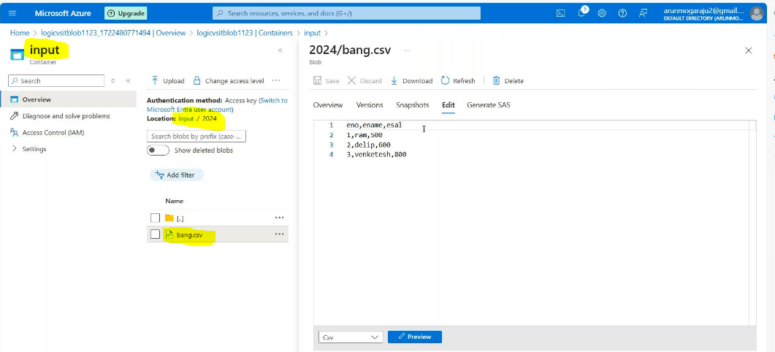

Create gen 2 storage:

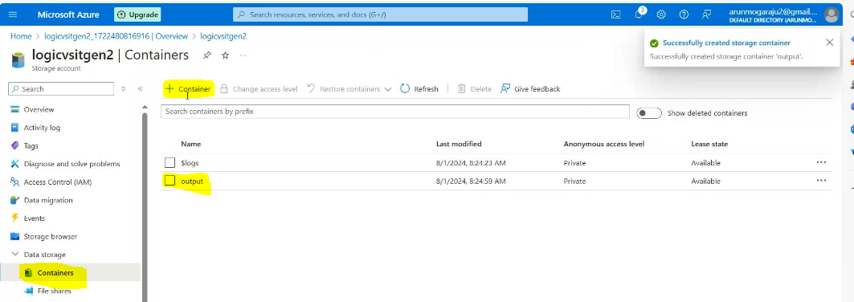

Create a logic app:

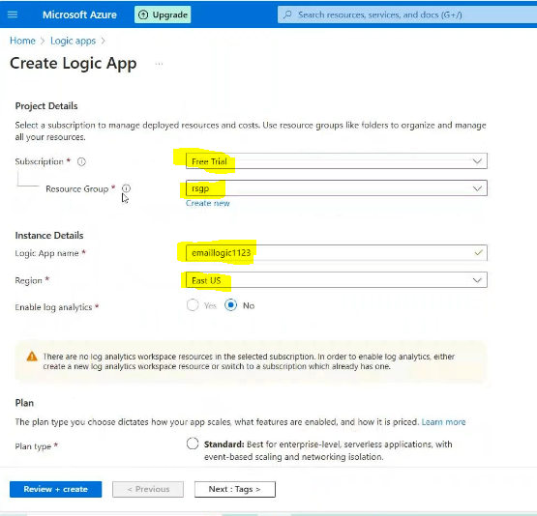

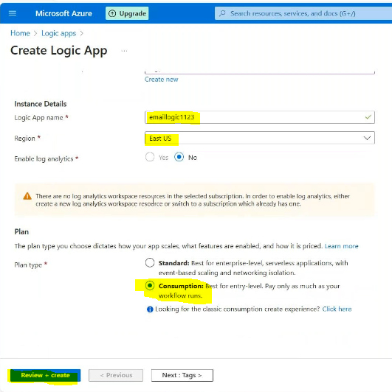

Then create adf :

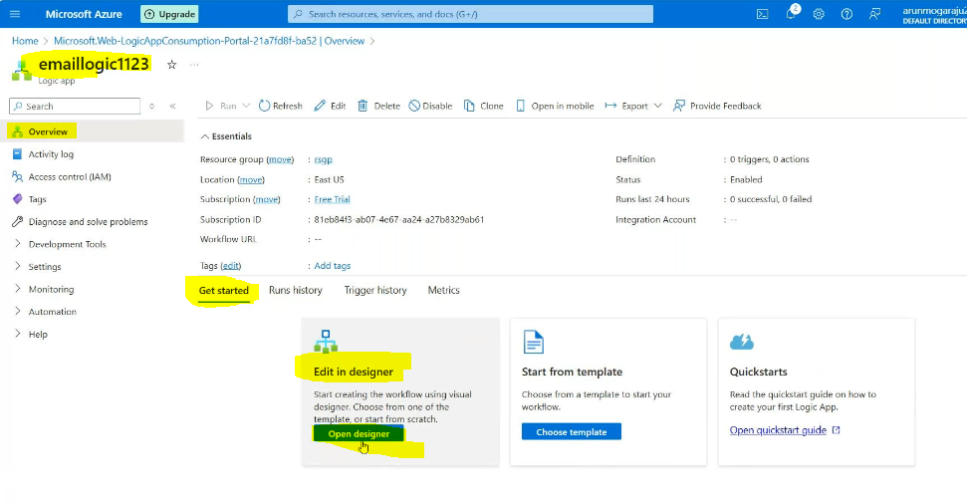

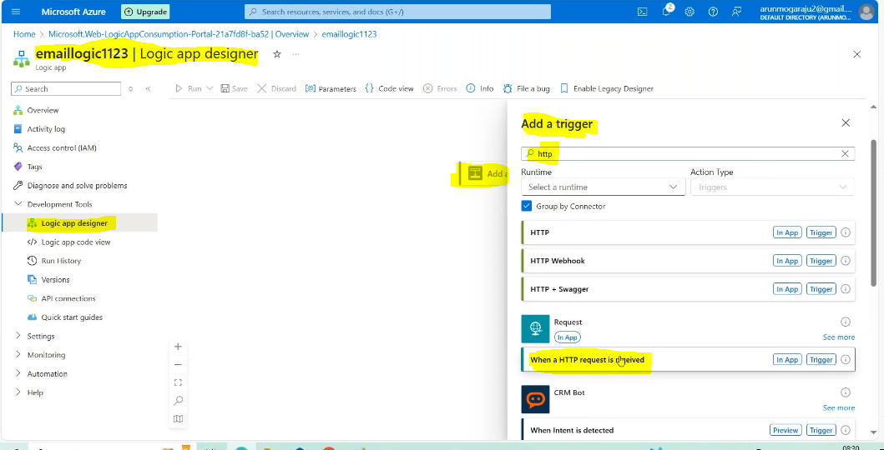

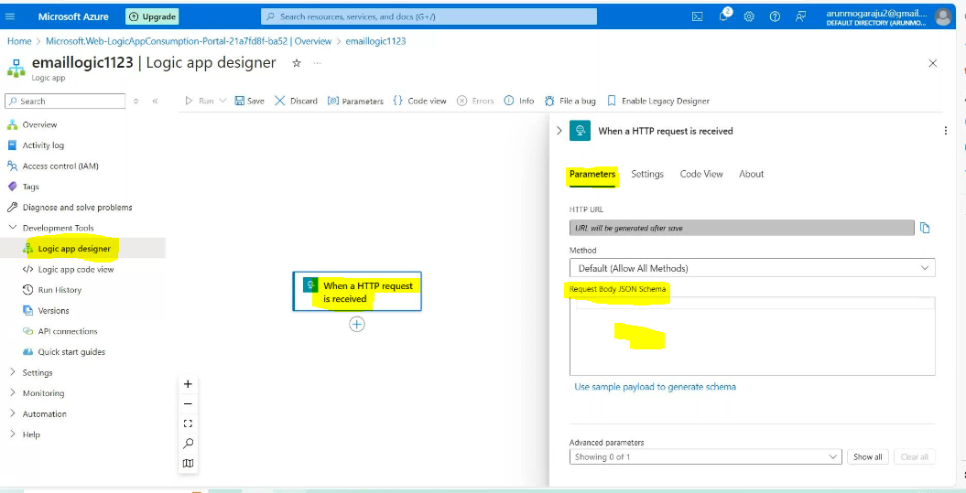

{

"properties": {

"DataFactoryName": {

"type": "string"

},

"EmailTo": {

"type": "string"

},

"ErrorMessage": {

"type": "string"

},

"PipelineName": {

"type": "string"

},

"status": {

"type": "string"

}

},

"type": "object"

}

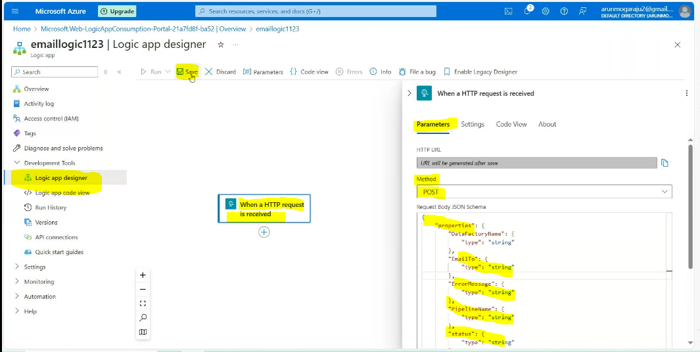

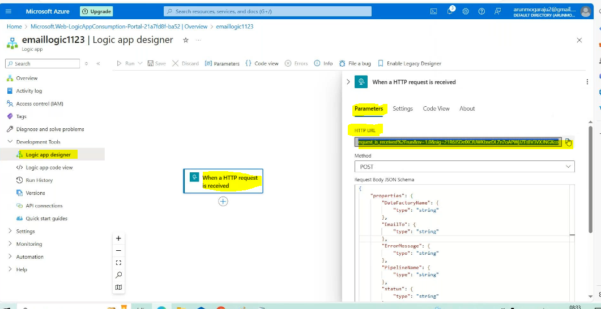

Save it in notepad;

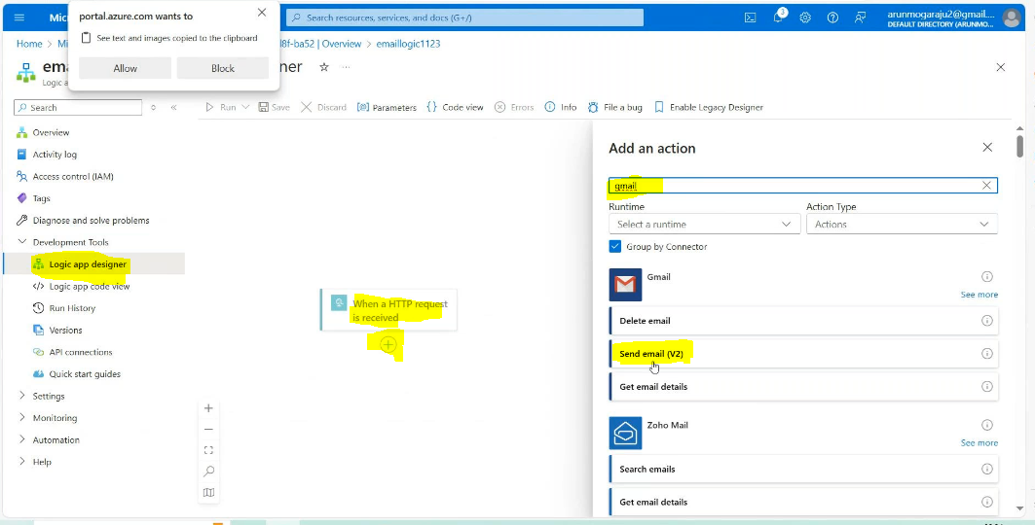

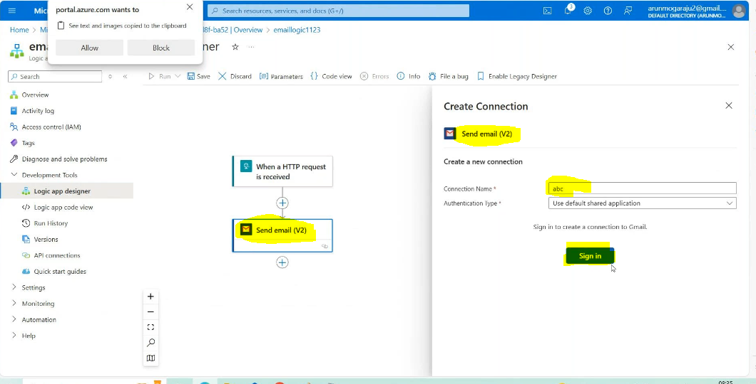

Sign in with our mail:Then

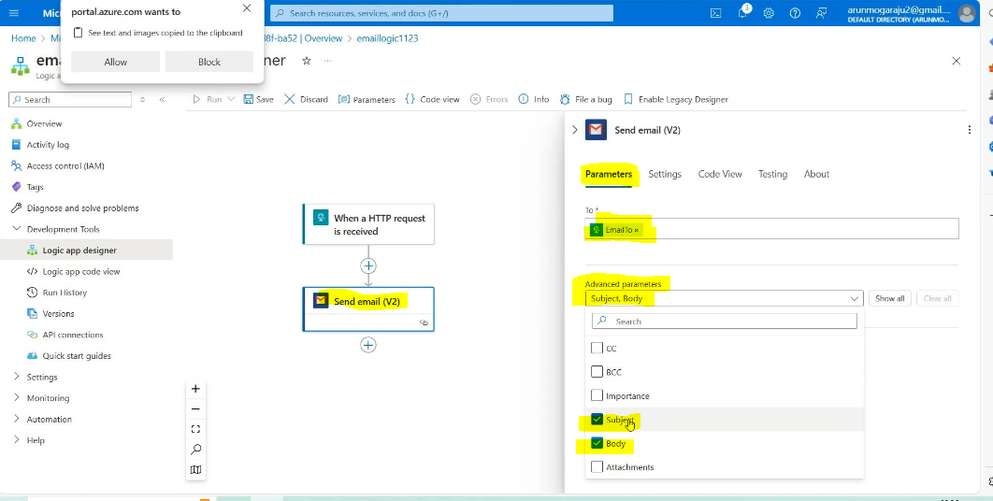

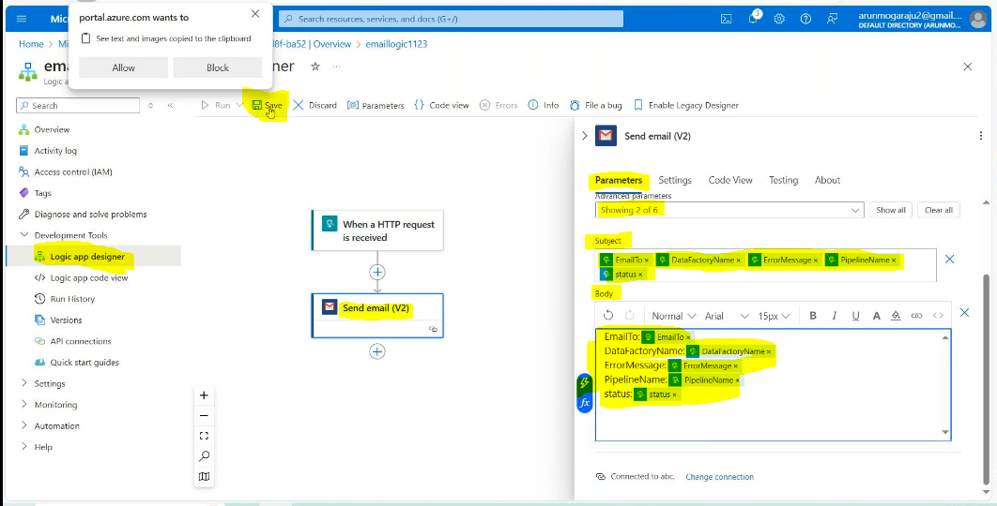

Create linked services:

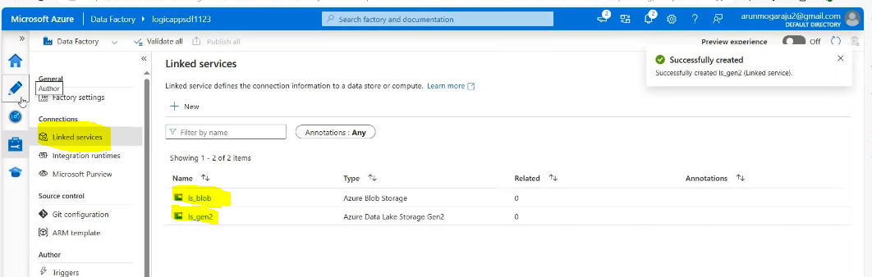

Create datasets fro source side:  
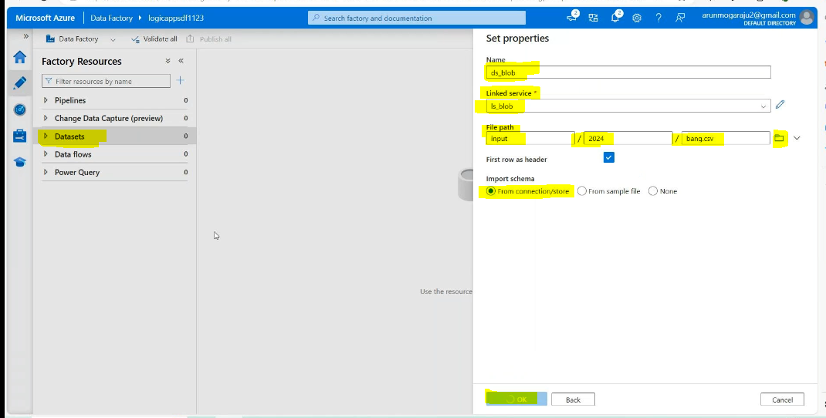

Create datasets fro sink side:

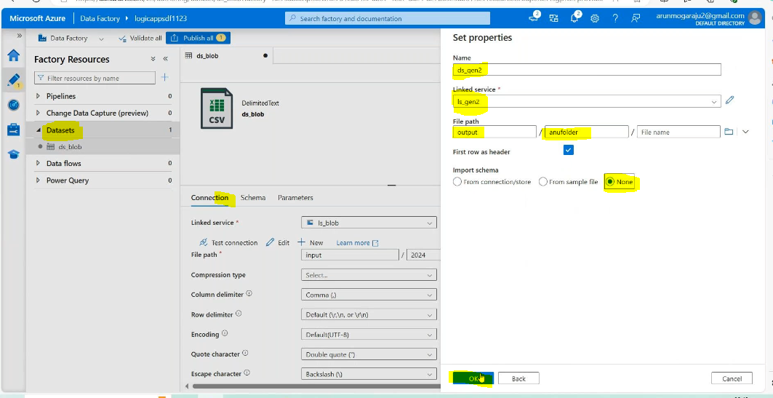

Creat a pipeline 🡪copy data activity🡪

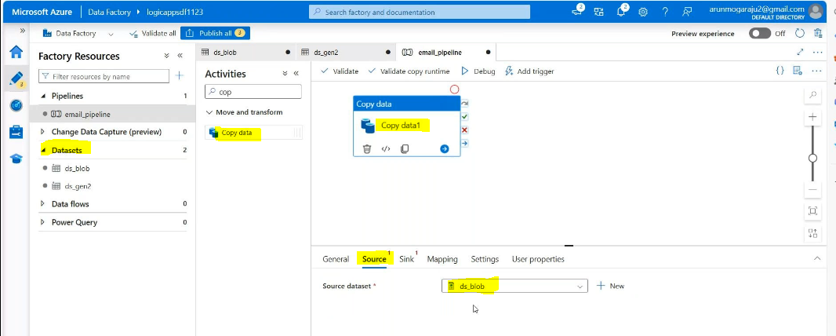

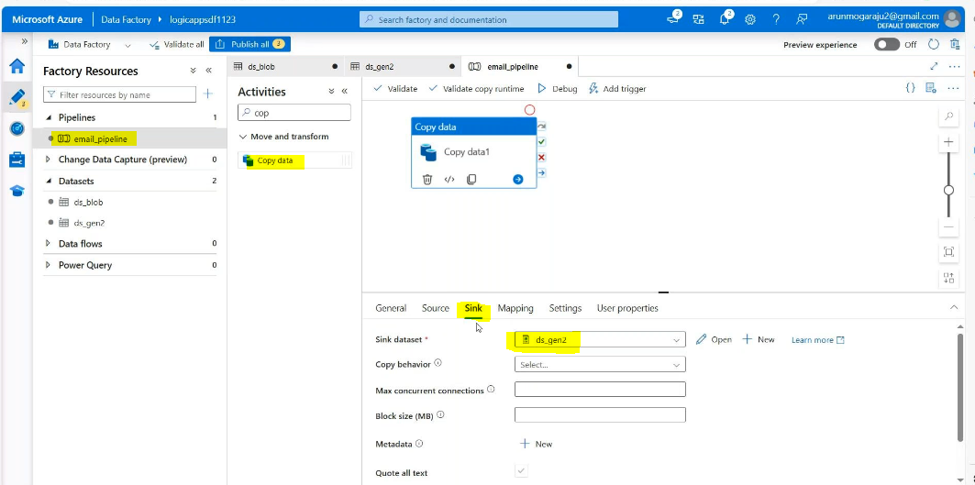

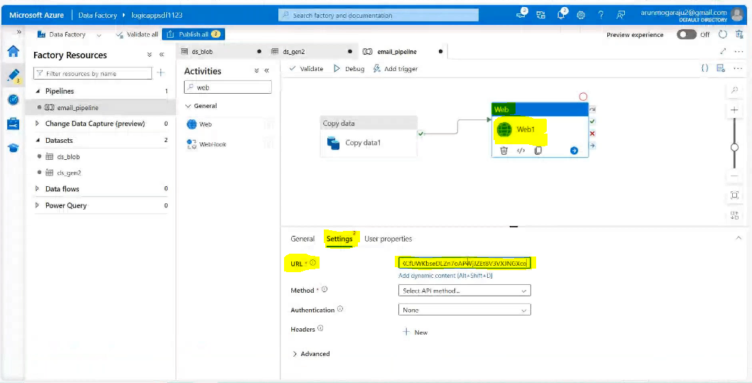

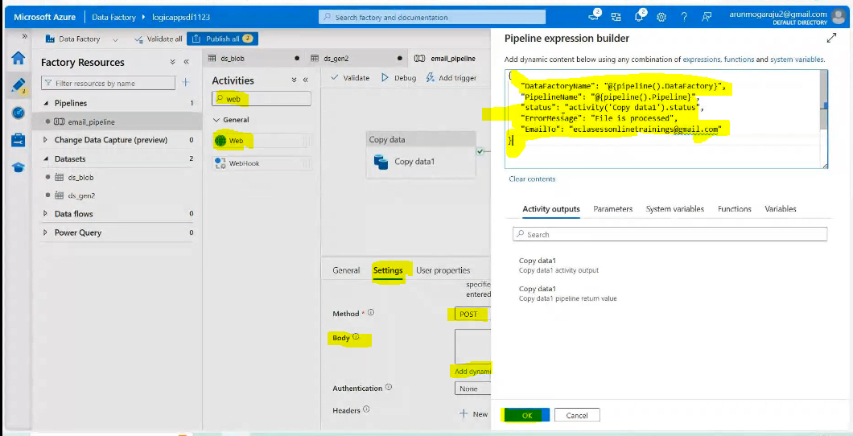

{

"DataFactoryName": "@{pipeline().DataFactory}",

"PipelineName": "@{pipeline().Pipeline}",

"status": "activity('Copy data1').status",

"ErrorMessage": "File is processed",

"EmailTo": "moguramgoverdhan@gmail.com"

}

Results:

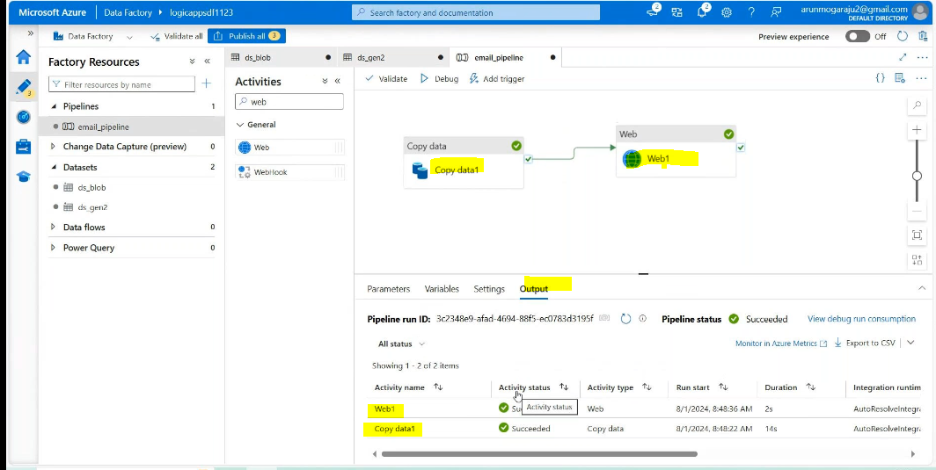

Failure activity:

